**Building Scalable APIs: A Practical Guide Using Java**

In today’s software development landscape, building **scalable** and **maintainable APIs** is critical for robust backend systems. Whether you are creating a small product or an enterprise-grade platform, your API structure defines how your services interact and grow. In this blog, we’ll explore how to build scalable **RESTful APIs using Java**, along with some best practices for designing modular and production-ready backends.

**🧩 Why Scalability Matters**

Scalability ensures that your API can handle an increasing number of users or requests without degrading performance. Poorly designed APIs often become bottlenecks, affecting the entire application experience.

**⚙️ Tech Stack Overview**

* **Language**: Java 17+
* **Framework**: Spring Boot
* **Architecture**: RESTful Microservices
* **Database**: MySQL / PostgreSQL
* **Tools**: Postman, Swagger UI, Spring Actuator, Docker

**🛠️ Steps to Build Scalable REST APIs**

**1. Use Layered Architecture (Controller-Service-Repository) :** This approach separates concerns and improves maintainability.

// Controller

@RestController

@RequestMapping("/api/products")

public class ProductController {

private final ProductService service;

@GetMapping public List<Product> getAll() {

return service.getAllProducts();

}

}

**2. DTO Pattern for Clean Data Transfer**

Avoid exposing your entities directly. Use Data Transfer Objects (DTOs) to structure incoming and outgoing data.

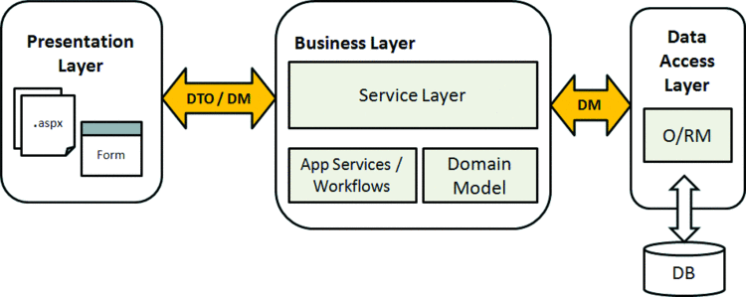

public class ProductDTO {

private String name;

private double price;

}

**3. Handle Exceptions Gracefully**

Use @ControllerAdvice and @ExceptionHandler for centralized error handling.

@RestControllerAdvice

public class GlobalExceptionHandler {

@ExceptionHandler(ResourceNotFoundException.class)

public ResponseEntity<?> handleNotFound(ResourceNotFoundException ex) {

return ResponseEntity.status(HttpStatus.NOT_FOUND).body(ex.getMessage());

}

}

**4. Paginate & Filter Responses**

Don’t return everything at once—especially in production environments. Use pagination via Pageable.

@GetMapping

public Page<ProductDTO> getAll(Pageable pageable) {

return productService.getPaginatedProducts(pageable);

}

**5. Use Swagger/OpenAPI for Documentation**

Integrate Swagger using SpringDoc OpenAPI:

<dependency>

<groupId>org.springdoc</groupId>

<artifactId>springdoc-openapi-ui</artifactId>

<version>1.6.14</version>

</dependency>

Access docs at <http://localhost:8080/swagger-ui.html>.

**6. Secure Your APIs**

Use **Spring Security** and implement OAuth2/JWT for token-based authentication.

OAuth2  
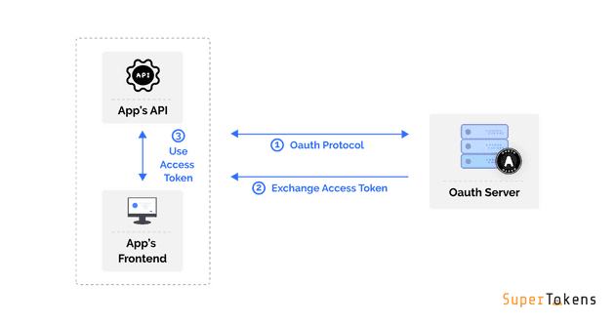

JWT  
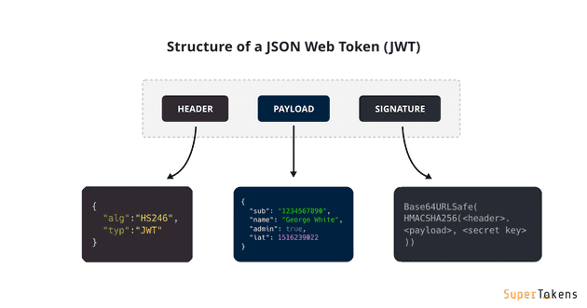

**7. Monitor & Optimize**

Integrate **Spring Boot Actuator** and **Prometheus + Grafana** for real-time monitoring of API health and metrics.

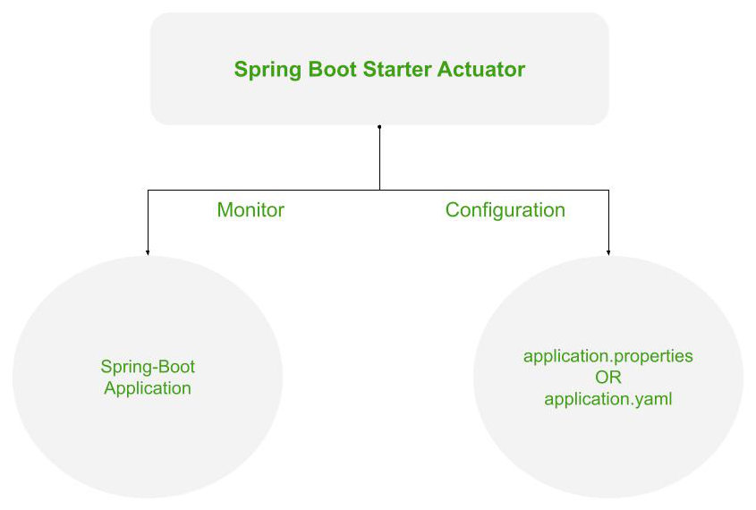

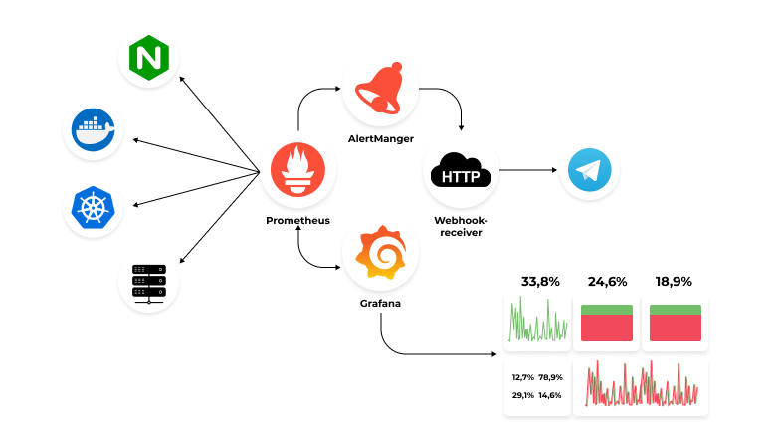

**🧪 Testing Tips**

* Use **JUnit** and **Mockito** for unit and integration testing.
* Test edge cases, null values, and API failures.
* Automate with **Postman Collections** or **REST Assured**.

**🚀 Deploying Your APIs**

Package your application using:- **./mvnw clean package**

Run it as:- **java -jar target/api-service.jar**

For scalability, consider deploying via:

* Docker (containerization)
* Kubernetes (orchestrating services)
* CI/CD with GitHub Actions or Jenkins

**✅ Best Practices Summary**

* Keep endpoints RESTful (GET, POST, PUT, DELETE)
* Use versioning: /api/v1/products
* Validate inputs using @Valid and @NotNull
* Avoid business logic in controllers
* Always write clean, well-documented code

**📌 Conclusion**

Building scalable APIs isn't just about handling large traffic—it's about writing **structured**, **modular**, and **reliable** code from the beginning. With Java and Spring Boot, you have powerful tools to ensure your APIs perform well, remain secure, and adapt to growing demands.

📎 **Want to learn more or collaborate?**  
Feel free to connect with me on [LinkedIn](https://www.linkedin.com/in/jmshines) or explore my [GitHub Projects](https://github.com/mjinesh940).